**DBMS LAB Assignment –7**

**NAME-SHISHU**

**REG 2020CA089**

Q.1) Consider a database that is being constructed for a Company’s office organization where it stores the value of Employees, their Bonus and Job title. The employee relation contains the details of id, first name, last name, salary, joining date of office and the department in which they are working. The Bonus relation contains the details of employee reference id, bonus date and amount of bonus. Title relate to bonus table through the reference id and this table stores the value of employer designation and their job affected from which date.

Consider the sales info system consisting of following schemas:-

**Employee** (E_id, First_Name, Last_Name, Salary, Joining_Date, Department)

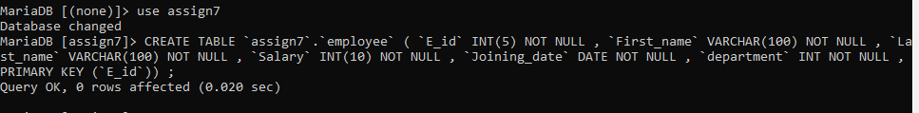

**Bonus** (E_Ref_Id, Bonus_Date, Bonus_Amount)



**Job_Title** (E_Ref_Id, E_Title, Affected_From)



Stabilized Relation Between Employee table to Bonus and Job_title table

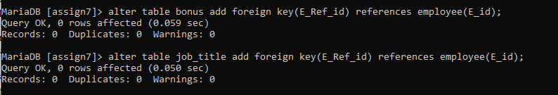

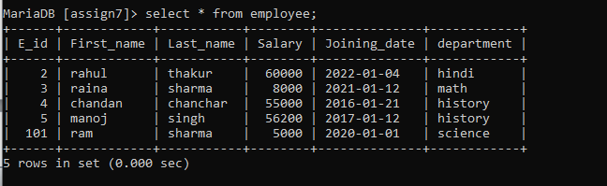

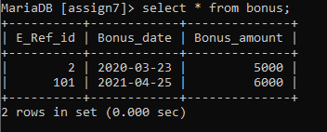

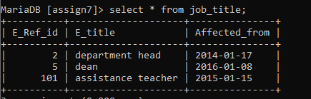

Write the SQL queries for the following with respect to database created: –

1. Fetch first name of worker using alias name as E_Name.

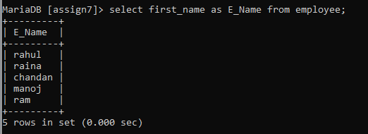

1. List the last name of employees in upper case.

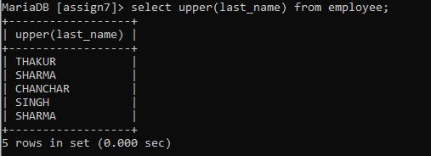

1. Retrieve the first three characters of employees from their first name.

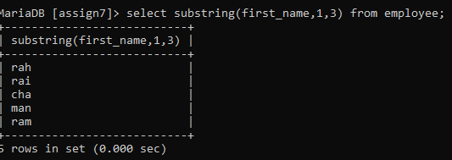

1. Retrieve the unique values of department and display its length.

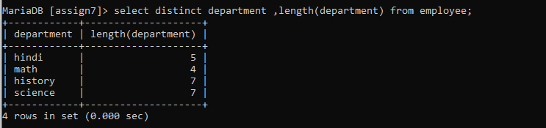

1. List the first name from employees table after replacing ‘a’ with ‘A’.

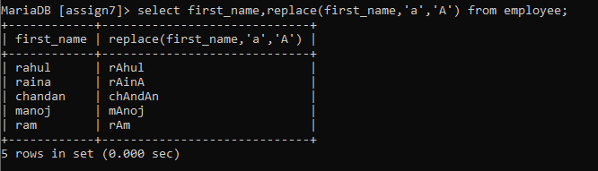

1. Display all worker details, use order by in first name asec and department in desc.

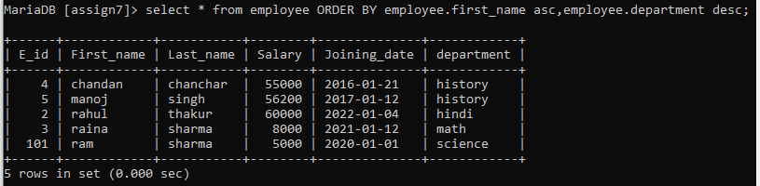

1. List the details of an employee whose first name ends with ‘h’ and contains six alphabets.

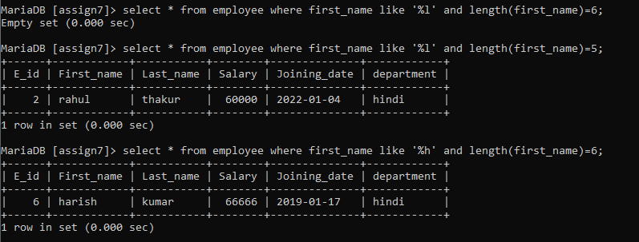

1. Display the details of employees who have joined in Feb 2014.

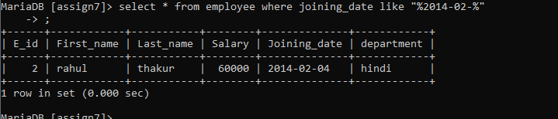

1. Fetch the employee’s names with salaries over and equal to 50000 and less than equal to 100000.

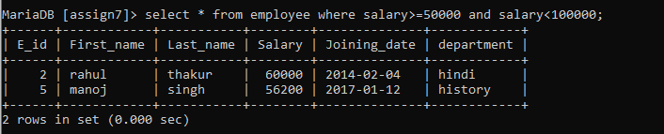

1. List the no. of employees for each department in desc order.

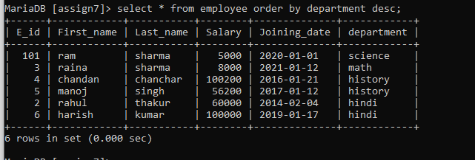

1. Print the details of employees who are also managers.

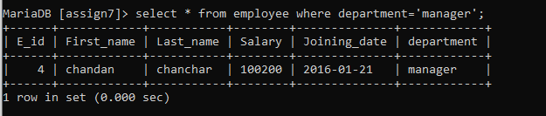

1. Fetch the duplicate records having matching data in some fields of a table.

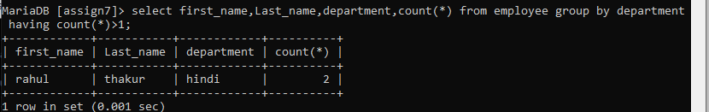

1. Fetch intersecting records of two tables.

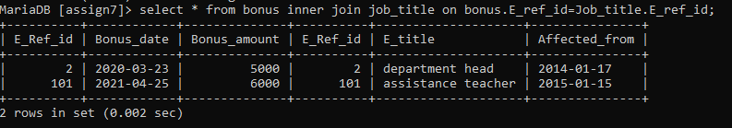

1. Find the nth (say n=5) highest salary from a table.

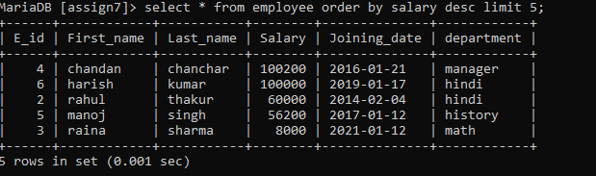

1. Find the 4th highest salary without using TOP or limit method.

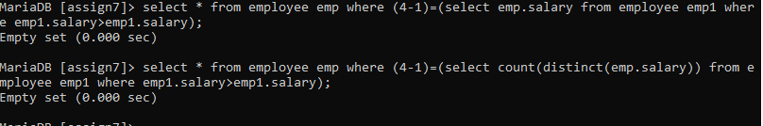

1. List the details of employees with the same salary.

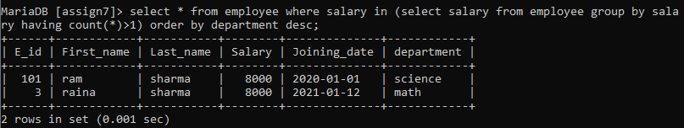

1. Display the second highest salary from a table.

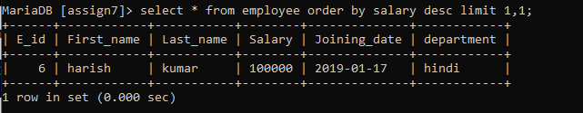

1. Display all departments along with the number of people in there.

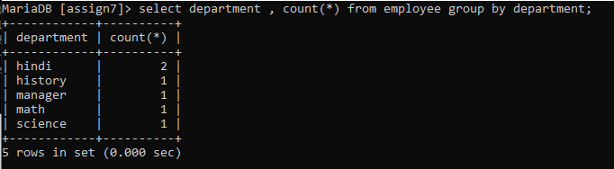

1. List the name of employees having the highest salary in each department.

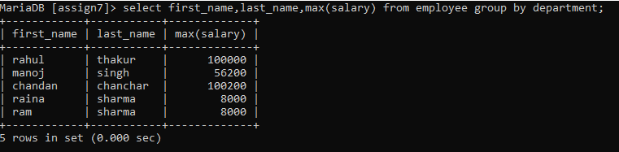

1. Fetch three min salaries from a table

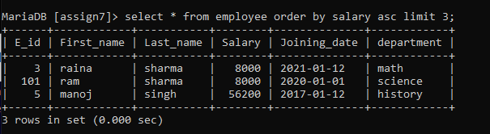

1. Fetch departments along with the total salaries paid for each of them.

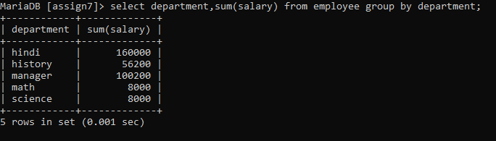

1. Fetch the names of employees who earn the highest salary.

